**Project Planning Phase**

**Project Planning Template (Product Backlog, Sprint Planning, Stories, Story points)**

|  |  |
| --- | --- |
| Date | 27 October 2023 |
| Team ID |  |
| Project Name | Sugarcane Production Analysis |
| Maximum Marks | 8 Marks |

**Product Backlog, Sprint Schedule, and Estimation (4 Marks)**

Use the below template to create product backlog and sprint schedule

| **Sprint** | **Functional Requirement (Epic)** | **User Story Number** | **User Story / Task** | **Story Points** | **Priority** | **Team Members** |
| --- | --- | --- | --- | --- | --- | --- |
| Sprint-1 | Project Setup and Development | USN-1 | Project Setup and Development | USN-1 | Set up the development environment with the required tools and frameworks to start the analysis of sugarcane production. Gather related data. | 2 | High | Sravani  Mrudhula  Keerthi  Benarji |
| Sprint-2 | Data Preprocessing | USN-2 | Preprocess the collected sugarcane production dataset, including data normalization and transformation. | 1 | High | All Members |
| Sprint-3 | Dashboards and Visualizations | USN-3 | Create visualizations and dashboards for the sugarcane production data and perform analysis using suitable algorithms. | 2 | Medium | All Members |
| Sprint-4 | Testing and Quality Assurance | USN-4 | Conduct thorough testing of the analytical models and the web interface to identify and report any issues or bugs. | 2 | Medium | All Members |

**Project Tracker, Velocity & Burndown Chart: (4 Marks)**

| **Sprint** | **Total Story Points** | **Duration** | **Sprint Start Date** | **Sprint End Date (Planned)** | **Story Points Completed (as on Planned End Date)** | **Sprint Release Date (Actual)** |
| --- | --- | --- | --- | --- | --- | --- |
| Sprint-1 | 5 | 3Days | 16 Oct 2022 | 18 Oct 2023 | 20 | 28 Oct 2022 |
| Sprint-2 | 5 | 3Days | 21Oct 2022 | 23 Oct 2023 |  |  |
| Sprint-3 | 5 | 5Days | 01Nov 2022 | 5 Nov 2023 |  |  |
| Sprint-4 | 5 | 3Days | 7Nov 2022 | 9 Nov 2023 |  |  |
|  |  |  |  |  |  |  |
|  |  |  |  |  |  |  |
|  |  |  |  |  |  |  |
|  |  |  |  |  |  |  |

**Velocity:**

Imagine we have a 10-day sprint duration, and the velocity of the team is 20 (points per sprint). Let’s calculate the team’s average velocity (AV) per iteration unit (story points per day)

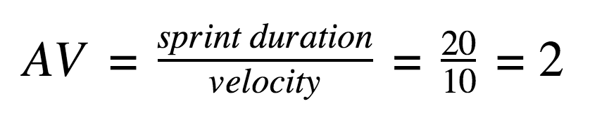

**Burndown Chart:**

A burndown chart is a graphical representation of work left to do versus time. It is often used in agile[software development](https://www.visual-paradigm.com/scrum/what-is-agile-software-development/) methodologies such as [Scrum](https://www.visual-paradigm.com/scrum/scrum-in-3-minutes/). However, burn down charts can be applied to any project containing measurable progress over time.

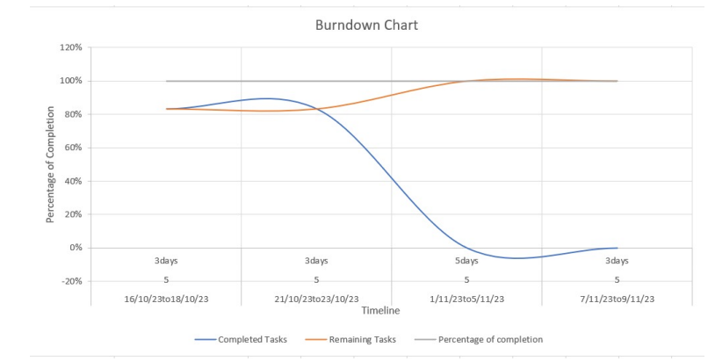

[**https://www.visual-paradigm.com/scrum/scrum-burndown-chart/**](https://www.visual-paradigm.com/scrum/scrum-burndown-chart/)

[**https://www.atlassian.com/agile/tutorials/burndown-charts**](https://www.atlassian.com/agile/tutorials/burndown-charts)

**Reference:**

[**https://www.atlassian.com/agile/project-management**](https://www.atlassian.com/agile/project-management)

[**https://www.atlassian.com/agile/tutorials/how-to-do-scrum-with-jira-software**](https://www.atlassian.com/agile/tutorials/how-to-do-scrum-with-jira-software)

[**https://www.atlassian.com/agile/tutorials/epics**](https://www.atlassian.com/agile/tutorials/epics)

[**https://www.atlassian.com/agile/tutorials/sprints**](https://www.atlassian.com/agile/tutorials/sprints)

[**https://www.atlassian.com/agile/project-management/estimation**](https://www.atlassian.com/agile/project-management/estimation)

[**https://www.atlassian.com/agile/tutorials/burndown-charts**](https://www.atlassian.com/agile/tutorials/burndown-charts)